Datasets links
Primary recommendation: NHANES (National Health and Nutrition Examination Survey, CDC)
This is genuinely your best option and what most of the papers I found for you actually use. It's free, no application process, and has almost everything you need in one place: CBC (haemoglobin, MCV, RDW, etc.), HbA1c, fasting glucose, OGTT, demographics, BMI, and — in specific cycles only — ferritin.
- Main portal: https://wwwn.cdc.gov/nchs/nhanes/Default.aspx
- Direct data files by cycle: https://wwwn.cdc.gov/nchs/nhanes/search/default.aspx (searchable by variable — search "glycohemoglobin," "complete blood count," "ferritin")
- Important caveat you should plan around: ferritin is not measured in every cycle — it's only available in NHANES 2005–2010 and NHANES 2015–2018, so if you want ferritin as a feature, you must restrict your cohort to those specific cycles rather than the full NHANES history. nih
- Reticulocyte count and haptoglobin (the ones I flagged as ideal for catching haemolysis) are not routinely available in NHANES — worth stating explicitly in your "limitations/scope" section as I mentioned earlier.
Secondary/supplementary options:
- Kaggle — Diabetes Health Indicators / CDC Diabetes datasets: https://www.kaggle.com/datasets/alexteboul/diabetes-health-indicators-dataset — pre-cleaned NHANES-derived version, faster to start with for prototyping, but check exactly which variables survived the cleaning before relying on it for CBC indices.
- MIMIC-IV (ICU data, PhysioNet): https://physionet.org/content/mimiciv/ — has CBC and HbA1c for hospitalized patients, but requires a credentialed access application (CITI training certificate) and is ICU-population-biased (sicker patients, not representative of routine screening) — better as a validation/robustness-check dataset later, not your primary training set.
- UK Biobank: https://www.ukbiobank.ac.uk/enable-your-research/apply-for-access — has excellent CBC + HbA1c + genetic data, but requires a formal application, a fee, and typically institutional sponsorship — likely too heavy a process for a capstone timeline unless your guide has existing access.

What's literally in the dataset
Each NHANES cycle is split into separate files linked by a participant ID (SEQN). For your project you'd pull and merge these:
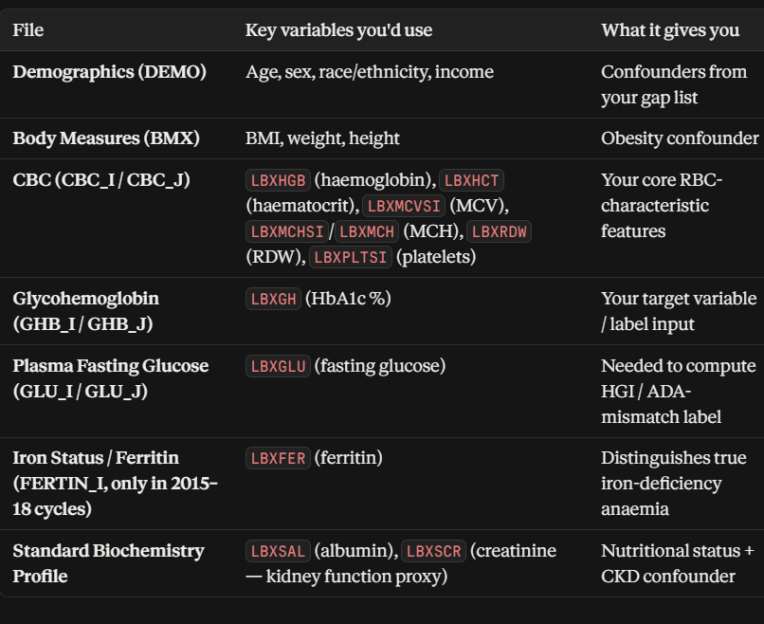

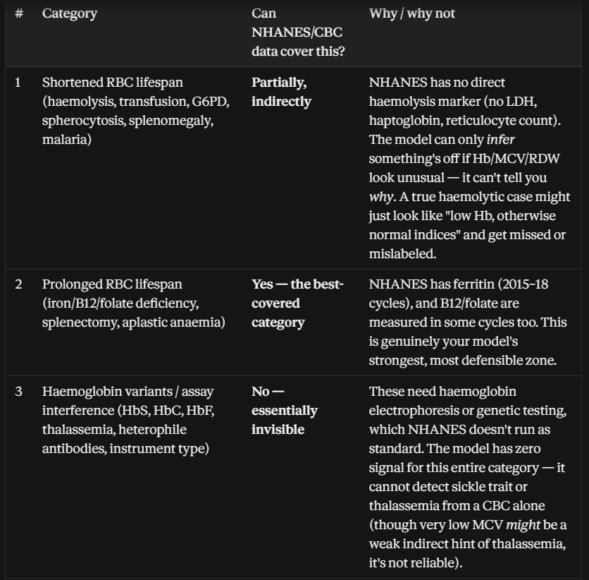
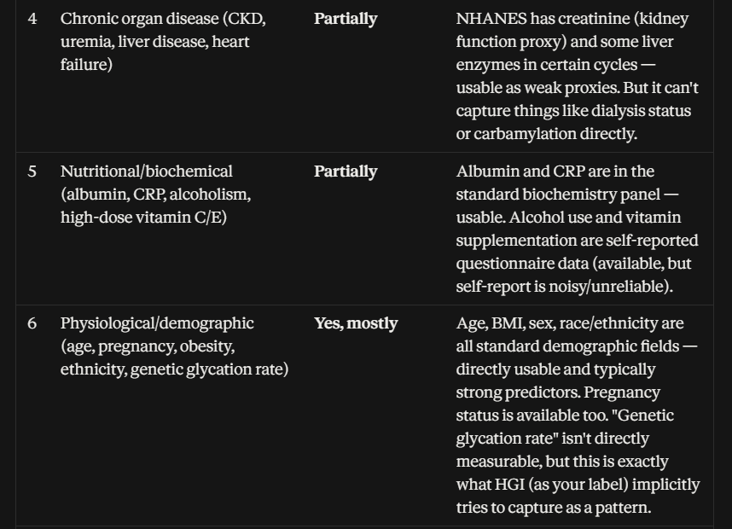
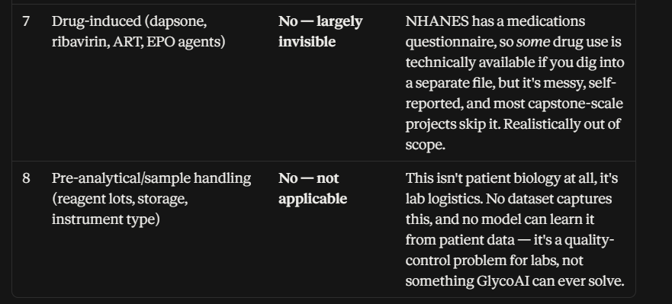

POST PANDEMIC AND PRE PANDEMIC DATA SETS FORM NHANES ARE BEEN COLLECTED AND MEREGED. BELOW PART TELLS ABOUT IT
Category | Select? | Reasoning tied to YOUR actual data | Research grounding
2 — Iron/nutritional deficiency anaemia | Yes — core | Both files already have LBXHGB, LBXMCVSI, LBXFER. This is your only category with zero additional engineering needed. | Iron-deficiency anaemia's effect on HbA1c is the most consistently replicated finding across multiple independent cohort studies — the strongest evidence base of any category we've reviewed.
6 — Demographic/physiological | Yes — core | Pre-pandemic has full demographics; post-pandemic doesn't yet — fixable (see code below), not a hard gap. | Age is repeatedly shown as one of the strongest independent predictors of HbA1c-glucose mismatch in large-cohort HGI studies.
5 — Nutritional/inflammatory (CRP, albumin) | Yes — partial, now stronger than we thought | Your teammate's post-pandemic file already includes LBXHSCRP (CRP) — genuinely good, this is more than your pre-pandemic file has. Fixable by fetching CRP for pre-pandemic too (code below). | CRP/inflammation is documented as an independent factor influencing glycation biology, distinct from anaemia.
2b — B12/folate deficiency (megaloblastic anaemia) | Yes — newly upgradeable | Post-pandemic already has LBDRFO (RBC folate)! This is a real, unexpected asset — we should add folate to pre-pandemic to match. | Folate/B12 deficiency causing megaloblastic anaemia is a well-documented, distinct mechanism from iron-deficiency, with a consistent falsely-high HbA1c direction.
4 — Kidney/organ (creatinine) | Yes — partial | Pre-pandemic has LBXSCR; post-pandemic doesn't yet — fixable. | Creatinine as a CKD proxy is a standard, validated approach in nephrology-adjacent HbA1c research.
1 — Haemolysis (bilirubin) | No, for now | Neither file has LBXSTB. Addable, but adds a third subsample-dependent column stacking onto glucose+ferritin+folate — real risk of shrinking usable rows too far. Recommend deferring until you see how much Categories 2/5/6 already cost you in row count. | We already found bilirubin's signal is weak/non-specific for haemolysis even when present — lower payoff for the added missing-data cost.
3, 7, 8 — Variants, drugs, lab handling | No | Genuinely absent from NHANES entirely, any cycle — this hasn't changed. | Confirmed via CDC's own interference documentation — a structural data  ceiling, not a choice.
Sources used
NHANES 2017-March 2020: Standard Biochemistry Profile DocumentationOfficial CDC documentation confirming bilirubin (LBXSTB), albumin (LBXSAL), and creatinine (LBXSCR) are all included in this cycle's biochemistry panel.CDC/NHANES
NHANES 2017-March 2020: Folate - Serum and RBC Data FileConfirms serum and RBC folate variables are measured in your exact target cycle, supporting Category 2 (nutritional deficiency anaemia) inclusion.CDC/NHANES
NHANES 2017-March 2020: Folate Forms - Serum Data FileSupplementary documentation on how folate concentrations were measured (LC-MS/MS) for this cycle.CDC/NHANES
